React is a JavaScript library developed and licensed by Facebook. It represents V (View) in MVC (Model View Controller). React JS can react to changes in application state. SharePoint Framework itself is built using React JS.  
  
**Create SPFx Solution**Open a command prompt. Create a directory for SPFx solution

1. md spfx-crud-reactjs

Navigate to the above-created directory

1. cd spfx-crud-reactjs

Run Yeoman SharePoint Generator to create the solution

1. yo @microsoft/sharepoint

Yeoman generator will present you with the wizard by asking questions about the solution to be created.

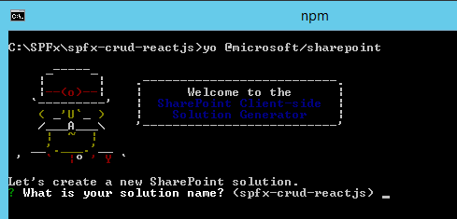

**Solution Name**Hit enter to have a default name (spfx-crud-reactjs in this case) or type in any other name for your solution.  
  
Selected choice - Hit enter

**Target for component**Here, we can select the target environment where we are planning to deploy the client web part; i.e., SharePoint Online or SharePoint OnPremise (SharePoint 2016 onwards).  
  
Selected choice - SharePoint Online only (latest)

**Place of files**We may choose to use the same folder or create a subfolder for our solution.  
  
Selected choice - Same folder

**Deployment option**Selecting Y will allow the app to be deployed instantly to all sites and will be accessible everywhere.  
  
Selected choice - N (install on each site explicitly)

**Type of client-side component to create**We can choose to create a client-side web part or an extension. Choose web part option.  
  
Selected choice - WebPart

**Web part name**Hit enter to select the default name or type in any other name.  
  
Selected choice - ReactCRUD

**Web part description**Hit enter to select the default description or type in any other value.  
  
Selected choice - CRUD operations with React JS

**Framework to use**Select any JavaScript framework to develop the component. Available choices are (No JavaScript Framework, React, and Knockout)  
  
Selected choice - React

Yeoman generator will perform a scaffolding process to generate the solution. The scaffolding process will take a significant amount of time.

Once the scaffolding process is completed, lock down the version of project dependencies by running the below command

1. npm shrinkwrap

In the command prompt type the below command to open the solution in the code editor of your choice.

1. code .

**Configure Property for List Name**SPFx solution by default has description property created. Let us change the property to list name. We will use this property to configure the list name on which the CRUD operation is to perform.

**Step 1**  
Open mystrings.d.ts under "\src\webparts\reactCrud\loc\" folder  
  
**Step 2**  
Rename DescriptionFieldLabel to ListNameFieldLabel

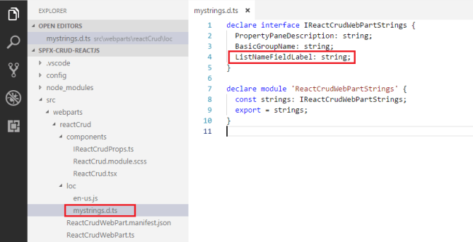

declare **interface** IReactCrudWebPartStrings {

  PropertyPaneDescription: string;

  BasicGroupName: string;

  ListNameFieldLabel: string;

}

declare module 'ReactCrudWebPartStrings' {

**const** strings: IReactCrudWebPartStrings;

**export** = strings;

}

**Step 3**  
In en-us.js file under "\src\webparts\reactCrud \loc\" folder set the display name for listName property

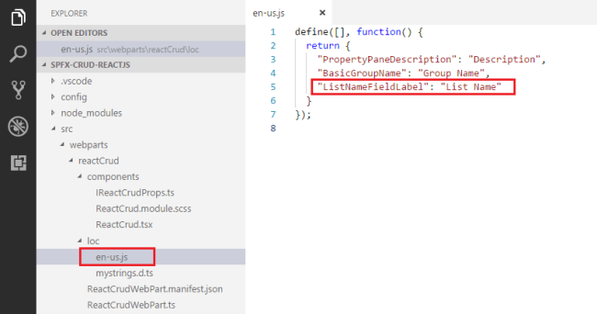

1. define([], **function**() {
2. **return** {
3. "PropertyPaneDescription": "Description",
4. "BasicGroupName": "Group Name",
5. "ListNameFieldLabel": "List Name"
6. }
7. });

**Step 4**  
In the interface IReactCrudProps.ts under "\src\webparts\reactCrud\components\", set the member name to listName

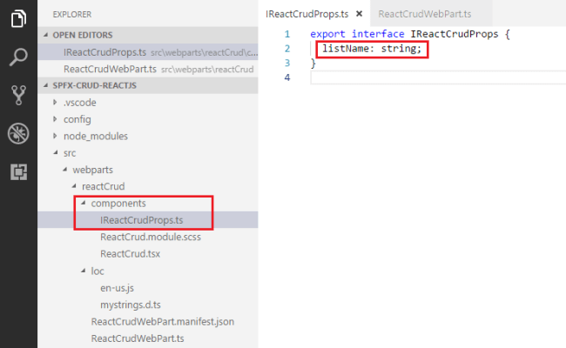

1. export **interface** IReactCrudProps {
2. listName: string;
3. }

**Step 5**  
Open the main webpart file (ReactCrudWebPart.ts) under "\src\webparts\reactCrud" folder.  
  
**Step 6**  
Rename description property pane field to listName

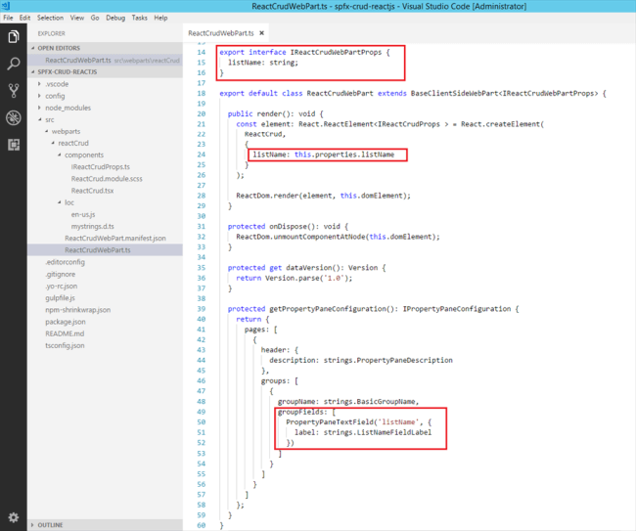

**export** **interface** IReactCrudWebPartProps {

  listName: string;

}

**export** **default** **class** ReactCrudWebPart **extends** BaseClientSideWebPart<IReactCrudWebPartProps> {

**public** render(): **void** {

**const** element: React.ReactElement<IReactCrudProps > = React.createElement(

      ReactCrud,

      {

        listName: **this**.properties.listName,

        spHttpClient: **this**.context.spHttpClient,

        siteUrl: **this**.context.pageContext.web.absoluteUrl

      }

    );

    ReactDom.render(element, **this**.domElement);

  }

**protected** onDispose(): **void** {

    ReactDom.unmountComponentAtNode(**this**.domElement);

  }

**protected** get dataVersion(): Version {

**return** Version.parse('1.0');

  }

**protected** getPropertyPaneConfiguration(): IPropertyPaneConfiguration {

**return** {

      pages: [

        {

          header: {

            description: strings.PropertyPaneDescription

          },

          groups: [

            {

              groupName: strings.BasicGroupName,

              groupFields: [

                PropertyPaneTextField('listName', {

                  label: strings.ListNameFieldLabel

                })

              ]

            }

          ]

        }

      ]

    };

  }

}

**Step 7**  
The UI in React gets served from component ReactCrud.tsx under "\src\webparts\reactCrud\components\ReactCrud.tsx". Make the changes for listName property in the component.

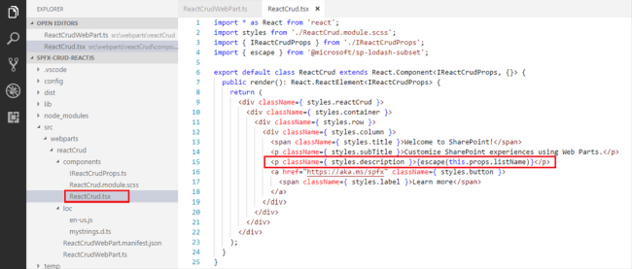

**import** * as React from 'react';

**import** styles from './ReactCrud.module.scss';

**import** { IReactCrudProps } from './IReactCrudProps';

**import** { escape } from '@microsoft/sp-lodash-subset';

**export** **default** **class** ReactCrud **extends** React.Component<IReactCrudProps, {}> {

**public** render(): React.ReactElement<IReactCrudProps> {

**return** (

      <div className={ styles.reactCrud }>

        <div className={ styles.container }>

          <div className={ styles.row }>

            <div className={ styles.column }>

              <span className={ styles.title }>Welcome to SharePoint!</span>

              <p className={ styles.subTitle }>Customize SharePoint experiences using Web Parts.</p>

              <p className={ styles.description }>{escape(**this**.props.listName)}</p>

              <a href="https://aka.ms/spfx" **class**="${ styles.button }">

                <span **class**="${ styles.label }">Learn more</span>

              </a>

            </div>

          </div>

        </div>

      </div>

    );

  }

}

**Step 8**  
In the command prompt, type “gulp serve”  
  
**Step 9**  
In the SharePoint local workbench page, add the web part.  
  
**Step 10**  
Edit the web part to ensure the listName property pane field is getting reflected.

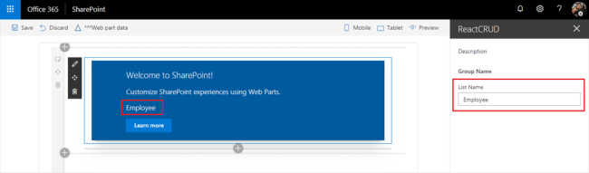

**Model for List Item  
  
Step 1**  
Add a class (IListItem.ts) representing the list item.

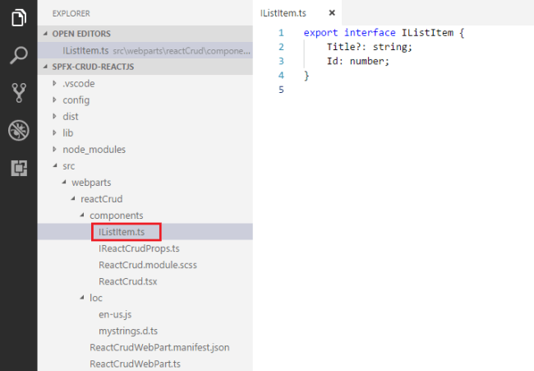

1. **export** **interface** IListItem {
2. Title?: string;
3. Id: number;
4. }

**Step 2**React JS acts on the state change. Let us add a state to our solution.

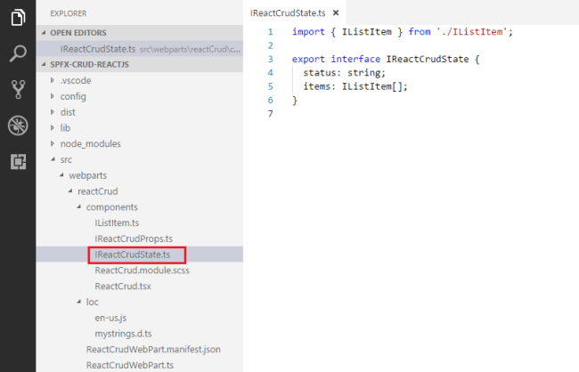

1. **import** { IListItem } from './IListItem';
3. **export** **interface** IReactCrudState {
4. status: string;
5. items: IListItem[];
6. }

**Step 3**  
Configure ReactCrud.tsx for this state

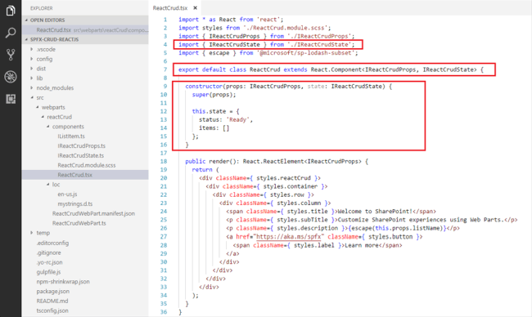

**import** * as React from 'react';

**import** styles from './ReactCrud.module.scss';

**import** { IReactCrudProps } from './IReactCrudProps';

**import** { IReactCrudState } from './IReactCrudState';

**import** { escape } from '@microsoft/sp-lodash-subset';

**export** **default** **class** ReactCrud **extends** React.Component<IReactCrudProps, IReactCrudState> {

  constructor(props: IReactCrudProps, state: IReactCrudState) {

**super**(props);

**this**.state = {

      status: 'Ready',

      items: []

    };

  }

**public** render(): React.ReactElement<IReactCrudProps> {

**return** (

      <div className={ styles.reactCrud }>

        <div className={ styles.container }>

          <div className={ styles.row }>

            <div className={ styles.column }>

              <span className={ styles.title }>Welcome to SharePoint!</span>

              <p className={ styles.subTitle }>Customize SharePoint experiences using Web Parts.</p>

              <p className={ styles.description }>{escape(**this**.props.listName)}</p>

              <a href="https://aka.ms/spfx" **class**="${ styles.button }">

                <span **class**="${ styles.label }">Learn more</span>

              </a>

            </div>

          </div>

        </div>

      </div>

    );

  }

}

**Add Controls to WebPart  
  
Step 1**  
Open ReactCrud.tsx under \src\webparts\reactCrud\components\ReactCrud.tsxfolder.  
  
**Step 2**  
Modify Render method to include buttons for CRUD operations and add event handlers to each of the buttons

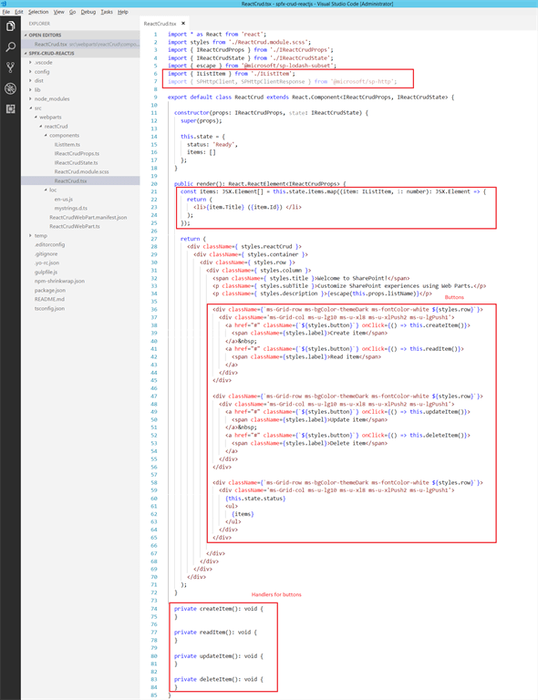

**import** * as React from 'react';

**import** styles from './ReactCrud.module.scss';

**import** { IReactCrudProps } from './IReactCrudProps';

**import** { IReactCrudState } from './IReactCrudState';

**import** { escape } from '@microsoft/sp-lodash-subset';

**import** { IListItem } from './IListItem';

**import** { SPHttpClient, SPHttpClientResponse } from '@microsoft/sp-http';

**export** **default** **class** ReactCrud **extends** React.Component<IReactCrudProps, IReactCrudState> {

  constructor(props: IReactCrudProps, state: IReactCrudState) {

**super**(props);

**this**.state = {

      status: 'Ready',

      items: []

    };

  }

**public** render(): React.ReactElement<IReactCrudProps> {

**const** items: JSX.Element[] = **this**.state.items.map((item: IListItem, i: number): JSX.Element => {

**return** (

        <li>{item.Title} ({item.Id}) </li>

      );

    });

**return** (

      <div className={ styles.reactCrud }>

        <div className={ styles.container }>

          <div className={ styles.row }>

            <div className={ styles.column }>

              <span className={ styles.title }>Welcome to SharePoint!</span>

              <p className={ styles.subTitle }>Customize SharePoint experiences using Web Parts.</p>

              <p className={ styles.description }>{escape(**this**.props.listName)}</p>

              <div className={`ms-Grid-row ms-bgColor-themeDark ms-fontColor-white ${styles.row}`}>

                <div className='ms-Grid-col ms-u-lg10 ms-u-xl8 ms-u-xlPush2 ms-u-lgPush1'>

                  <a href="#" className={`${styles.button}`} onClick={() => **this**.createItem()}>

                    <span className={styles.label}>Create item</span>

                  </a>

                  <a href="#" className={`${styles.button}`} onClick={() => **this**.readItem()}>

                    <span className={styles.label}>Read item</span>

                  </a>

                </div>

              </div>

              <div className={`ms-Grid-row ms-bgColor-themeDark ms-fontColor-white ${styles.row}`}>

                <div className='ms-Grid-col ms-u-lg10 ms-u-xl8 ms-u-xlPush2 ms-u-lgPush1'>

                  <a href="#" className={`${styles.button}`} onClick={() => **this**.updateItem()}>

                    <span className={styles.label}>Update item</span>

                  </a>

                  <a href="#" className={`${styles.button}`} onClick={() => **this**.deleteItem()}>

                    <span className={styles.label}>Delete item</span>

                  </a>

                </div>

              </div>

              <div className={`ms-Grid-row ms-bgColor-themeDark ms-fontColor-white ${styles.row}`}>

                <div className='ms-Grid-col ms-u-lg10 ms-u-xl8 ms-u-xlPush2 ms-u-lgPush1'>

                  {**this**.state.status}

                  <ul>

                    {items}

                  </ul>

                </div>

              </div>

            </div>

          </div>

        </div>

      </div>

    );

  }

**private** createItem(): **void** {

  }

**private** readItem(): **void** {

  }

**private** updateItem(): **void** {

  }

**private** deleteItem(): **void** {

  }

}

**Step 3**  
In the command prompt type “gulp serve” to see the buttons on web part.

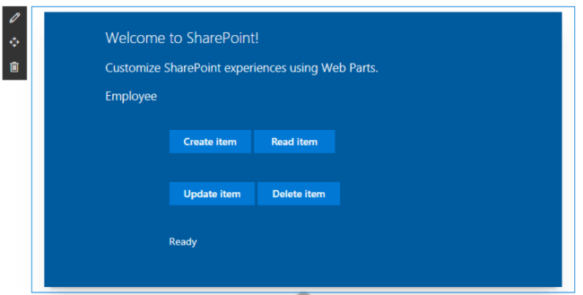

**Step 4**  
The read, update and delete operations will be performed on the latest item. Update interface IReactCrudProps.ts at "\src\webparts\reactCrud\components\ " to include site URL and spHttpClient

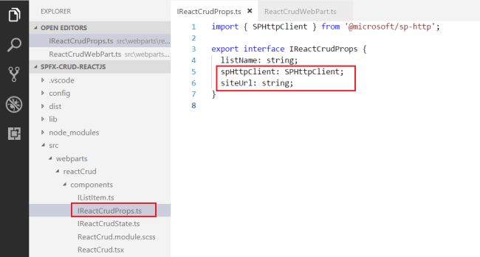

**import** { SPHttpClient } from '@microsoft/sp-http';

**export** **interface** IReactCrudProps {

  listName: string;

  spHttpClient: SPHttpClient;

  siteUrl: string;

}

**Step 5**  
Update "\src\webparts\reactCrud\ReactCrudWebPart.ts" to initiate site url and spHttpClient

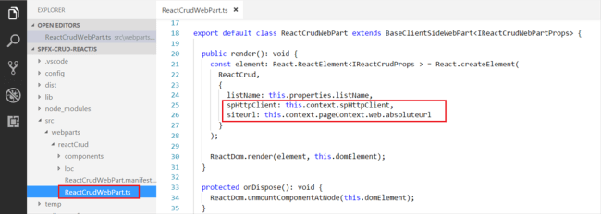

**export** **default** **class** ReactCrudWebPart **extends** BaseClientSideWebPart<IReactCrudWebPartProps> {

**public** render(): **void** {

**const** element: React.ReactElement<IReactCrudProps > = React.createElement(

      ReactCrud,

      {

        listName: **this**.properties.listName,

        spHttpClient: **this**.context.spHttpClient,

        siteUrl: **this**.context.pageContext.web.absoluteUrl

      }

    );

    ReactDom.render(element, **this**.domElement);

  }

**protected** onDispose(): **void** {

    ReactDom.unmountComponentAtNode(**this**.domElement);

  }

}

**Step 6**  
In ReactCrud.tsx implement generic method which will return the id of the latest item from the given list.

**private** getLatestItemId(): Promise<number> {

**return** **new** Promise<number>((resolve: (itemId: number) => **void**, reject: (error: any) => **void**): **void** => {

**this**.props.spHttpClient.get(`${**this**.props.siteUrl}/_api/web/lists/getbytitle('${this.props.listName}')/items?$orderby=Id desc&$top=1&$select=id`,

      SPHttpClient.configurations.v1,

      {

        headers: {

          'Accept': 'application/json;odata=nometadata',

          'odata-version': ''

        }

      })

      .then((response: SPHttpClientResponse): Promise<{ value: { Id: number }[] }> => {

**return** response.json();

      }, (error: any): **void** => {

        reject(error);

      })

      .then((response: { value: { Id: number }[] }): **void** => {

**if** (response.value.length === 0) {

          resolve(-1);

        }

**else** {

          resolve(response.value[0].Id);

        }

      });

  });

}

**Implement Create Operation**We will use the REST API to add the item to list.

**private** createItem(): **void** {

**this**.setState({

    status: 'Creating item...',

    items: []

  });

**const** body: string = JSON.stringify({

    'Title': `Item ${**new** Date()}`

  });

**this**.props.spHttpClient.post(`${**this**.props.siteUrl}/_api/web/lists/getbytitle('${this.props.listName}')/items`,

  SPHttpClient.configurations.v1,

  {

    headers: {

      'Accept': 'application/json;odata=nometadata',

      'Content-type': 'application/json;odata=nometadata',

      'odata-version': ''

    },

    body: body

  })

  .then((response: SPHttpClientResponse): Promise<IListItem> => {

**return** response.json();

  })

  .then((item: IListItem): **void** => {

**this**.setState({

      status: `Item '${item.Title}' (ID: ${item.Id}) successfully created`,

      items: []

    });

  }, (error: any): **void** => {

**this**.setState({

      status: 'Error while creating the item: ' + error,

      items: []

    });

  });

}

**Implement Read Operation**We will use the REST API to read the latest item.

**private** readItem(): **void** {

**this**.setState({

    status: 'Loading latest items...',

    items: []

  });

**this**.getLatestItemId()

    .then((itemId: number): Promise<SPHttpClientResponse> => {

**if** (itemId === -1) {

**throw** **new** Error('No items found in the list');

      }

**this**.setState({

        status: `Loading information about item ID: ${itemId}...`,

        items: []

      });

**return** **this**.props.spHttpClient.get(`${**this**.props.siteUrl}/_api/web/lists/getbytitle('${this.props.listName}')/items(${itemId})?$select=Title,Id`,

        SPHttpClient.configurations.v1,

        {

          headers: {

            'Accept': 'application/json;odata=nometadata',

            'odata-version': ''

          }

        });

    })

    .then((response: SPHttpClientResponse): Promise<IListItem> => {

**return** response.json();

    })

    .then((item: IListItem): **void** => {

**this**.setState({

        status: `Item ID: ${item.Id}, Title: ${item.Title}`,

        items: []

      });

    }, (error: any): **void** => {

**this**.setState({

        status: 'Loading latest item failed with error: ' + error,

        items: []

      });

    });

}

**Implement Update Operation**We will use the REST API to update the latest item.

**private** updateItem(): **void** {

**this**.setState({

    status: 'Loading latest items...',

    items: []

  });

  let latestItemId: number = undefined;

**this**.getLatestItemId()

    .then((itemId: number): Promise<SPHttpClientResponse> => {

**if** (itemId === -1) {

**throw** **new** Error('No items found in the list');

      }

      latestItemId = itemId;

**this**.setState({

        status: `Loading information about item ID: ${latestItemId}...`,

        items: []

      });

**return** **this**.props.spHttpClient.get(`${**this**.props.siteUrl}/_api/web/lists/getbytitle('${this.props.listName}')/items(${latestItemId})?$select=Title,Id`,

        SPHttpClient.configurations.v1,

        {

          headers: {

            'Accept': 'application/json;odata=nometadata',

            'odata-version': ''

          }

        });

    })

    .then((response: SPHttpClientResponse): Promise<IListItem> => {

**return** response.json();

    })

    .then((item: IListItem): **void** => {

**this**.setState({

        status: 'Loading latest items...',

        items: []

      });

**const** body: string = JSON.stringify({

        'Title': `Updated Item ${**new** Date()}`

      });

**this**.props.spHttpClient.post(`${**this**.props.siteUrl}/_api/web/lists/getbytitle('${this.props.listName}')/items(${item.Id})`,

        SPHttpClient.configurations.v1,

        {

          headers: {

            'Accept': 'application/json;odata=nometadata',

            'Content-type': 'application/json;odata=nometadata',

            'odata-version': '',

            'IF-MATCH': '*',

            'X-HTTP-Method': 'MERGE'

          },

          body: body

        })

        .then((response: SPHttpClientResponse): **void** => {

**this**.setState({

            status: `Item **with** ID: ${latestItemId} successfully updated`,

            items: []

          });

        }, (error: any): **void** => {

**this**.setState({

            status: `Error updating item: ${error}`,

            items: []

          });

        });

    });

}

**Implement Delete Operation**We will use the REST API to delete the latest item.

**private** deleteItem(): **void** {

**if** (!window.confirm('Are you sure you want to delete the latest item?')) {

**return**;

  }

**this**.setState({

    status: 'Loading latest items...',

    items: []

  });

  let latestItemId: number = undefined;

  let etag: string = undefined;

**this**.getLatestItemId()

    .then((itemId: number): Promise<SPHttpClientResponse> => {

**if** (itemId === -1) {

**throw** **new** Error('No items found in the list');

      }

      latestItemId = itemId;

**this**.setState({

        status: `Loading information about item ID: ${latestItemId}...`,

        items: []

      });

**return** **this**.props.spHttpClient.get(`${**this**.props.siteUrl}/_api/web/lists/getbytitle('${this.props.listName}')/items(${latestItemId})?$select=Id`,

        SPHttpClient.configurations.v1,

        {

          headers: {

            'Accept': 'application/json;odata=nometadata',

            'odata-version': ''

          }

        });

    })

    .then((response: SPHttpClientResponse): Promise<IListItem> => {

      etag = response.headers.get('ETag');

**return** response.json();

    })

    .then((item: IListItem): Promise<SPHttpClientResponse> => {

**this**.setState({

        status: `Deleting item **with** ID: ${latestItemId}...`,

        items: []

      });

**return** **this**.props.spHttpClient.post(`${**this**.props.siteUrl}/_api/web/lists/getbytitle('${this.props.listName}')/items(${item.Id})`,

        SPHttpClient.configurations.v1,

        {

          headers: {

            'Accept': 'application/json;odata=nometadata',

            'Content-type': 'application/json;odata=verbose',

            'odata-version': '',

            'IF-MATCH': etag,

            'X-HTTP-Method': 'DELETE'

          }

        });

    })

    .then((response: SPHttpClientResponse): **void** => {

**this**.setState({

        status: `Item **with** ID: ${latestItemId} successfully deleted`,

        items: []

      });

    }, (error: any): **void** => {

**this**.setState({

        status: `Error deleting item: ${error}`,

        items: []

      });

    });

}

**Test the WebPart**

1. On the command prompt, type “gulp serve”
2. Open SharePoint site
3. Navigate to /_layouts/15/workbench.aspx
4. Add the webpart to page.
5. Edit web part, in the properties pane, type the list name
6. Click the buttons (Create Item, Read Item, Update Item, and Delete Item) one by one to test the web part
7. Verify the operations are taking place in the SharePoint list.

**Create Operation**

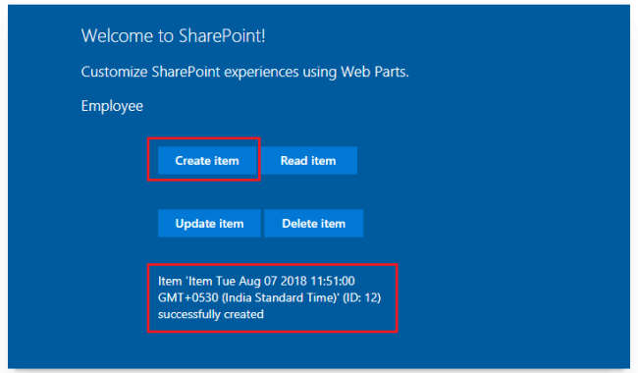

**Read Operation**

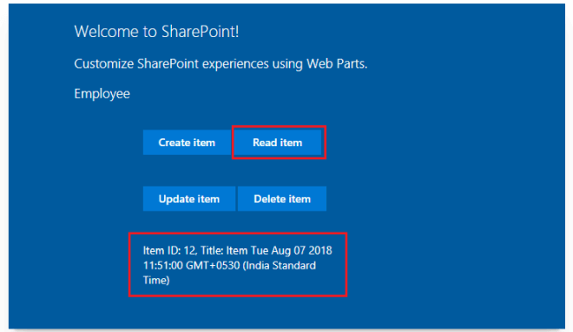

**Update Operation**

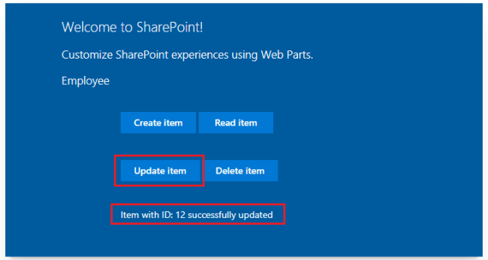

**Delete Operation**

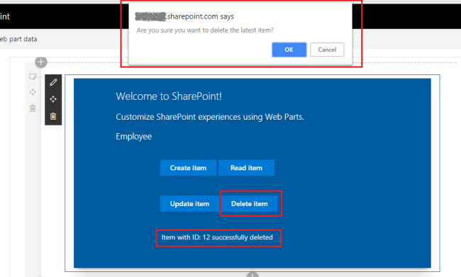

**Troubleshooting**In some cases, SharePoint workbench (https://[tenant].sharepoint.com/_layouts/15/workbench.aspx) shows the below error although “gulp serve” is running.

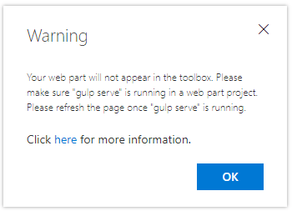

Open below URL in the next tab of the browser. Accept the warning message.  
  
*https://localhost:4321/temp/manifests.js***Summary**React JS is natively supported by SharePoint framework. SPFx generates all needed React components for you to get started with the development. React JS supports the application to be broken down into small React components, which simplifies development and maintenance. React JS focuses more on UI development, in contrast to Angular which is more famous for creating SPA (Single Page Applications).